Brussels, 30 June 2018

2nd PRESS RELEASE

MSTyr15 Has Improved Confidence of Energy Labels and Safety of Tyres

During the past 28 months, 14 EU Market Surveillance Authorities and Turkey have collaborated and successfully delivered the Market Surveillance Action on Tyres 2015 (MSTyr15) under the
co-ordination of PROSAFE. The goal of this H2020 project has been to enhance the functioning of the European Single Market by ensuring that the tyres regulatory measures are effectively enforced.

MSTyr15 is funded by the European Union and has run from March 2016 to the end of June 2018. The project involved the following countries: Belgium, Bulgaria, Croatia, Estonia, Finland, Germany, Ireland, Latvia, Lithuania, Luxembourg, Poland, Romania, Spain, Sweden and Turkey.

A total of 12.241 labels on C1 passenger car tyres have been checked by the participating Market Surveillance Authorities (MSAs) to see whether they meet the EC regulatory standards. Based on a EU market analysis, label inspections have been performed on tyres for both normal and extreme weather conditions. Altogether, 2.888 (23.5%) tyres have been examined in web shops and 627 (21.7%) of them were non-compliant. The investigation was also carried out in tyre depots, where 568 (6.1%) out of 9.353 tyres inspected proved to be non-compliant. The main non-conformities consisted out of either the label not showing at all or having the wrong format.

A sum of 131 passenger car tyres were sampled and sent to be tested by an accredited laboratory against the European Commission (EC) Regulation 1222/2009⁽⁾ regarding Wet Grip (WG) and Rolling Resistance (RR). Following repeated tests, five (5) models (3.8%) were found to be still non-compliant concerning WG, while nine (9) models (6.9%) did not meet the requirements for RR. No tyres failed both WG and RR.

Furthermore, 38% (334) of the 876 sets of technical documentation checked were either incomplete or failed to be delivered on time.

As a result of the activity, no tyres had to be withdrawn from the market. However, a number of agreed enforcement actions was adopted, including a total of 1.122 letters sent to Economic Operators requiring them to take corrective actions. For other 240 cases, the Economic Operators took voluntary measures to correct the non-compliances. It is important to take into account the fact that one letter concerned several models of tyres in many cases. As example it may cited that one authority sent 39 letters concerning 236 tyres.
Additionally, it is worth mentioning that due to the nature of market surveillance process and of this specific market, the enforcement actions may take months to be performed and go beyond the time frame of this Joint Action.

Innovating in terms of market surveillance data collection, MSTyr15 built a new bespoke database software. The database helped in harmonising the enforcement measures to be taken by the Member States, and, consequently, enhanced market confidence and consumer trust. Its results will be directly fed into the ICSMS⁽⁾ system and shared with all MSAs across Europe to enable immediate corrective action, thus saving significant inspection costs at the European level. The database together with the adopted Best Practice Guidelines overall ensure a cost-effective and consistent approach to real time knowledge exchange between MSAs across Europe.

Furthermore, to develop skills relevant to the scope of the project, MSTyr15 has created label inspection training videos in 15 languages and organised two (2) training workshops to prepare the participants to use the newly developed application software.
In terms of dissemination and exploitation, MSTyr15 has ensured that tyre suppliers are well informed about their responsibilities regarding the visibility of tyre label. The publication of the project results is expected to also increase awareness among consumers to choose more efficient and safer tyres.

To further communicate results, MSTyr15 was presented at two large international conferences (WSED2018 and EUSEW18). This demonstrates once more the consortium's strong and consistent commitment to achieve best value-for-money, by ensuring that the EU funds made available for the implementation of market surveillance projects pay off in terms of their impact on both the market and consumers.

Beyond its core scope, it is worth noting that MSTyr15 has established valuable relations with other non-participating MSAs across the European Economic Area, while liaising with a number of European associations, consumer organisations and environmental NGOs, therefore setting the ground for new synergies in the future.
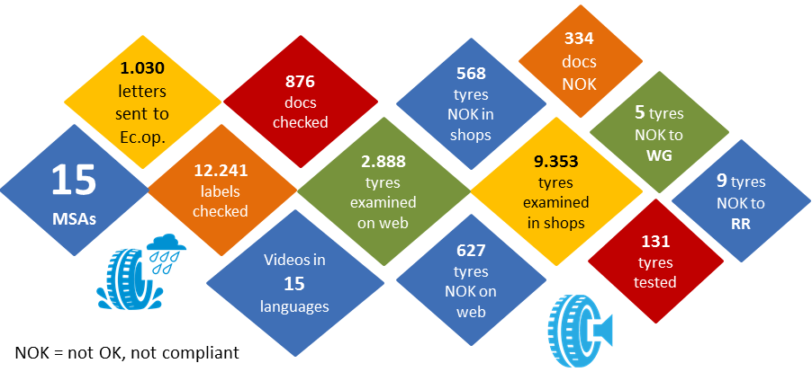

Contact Person:

Ioana Zlotila, Executive Director, ioana@prosafe.org and info@prosafe.org

Background information

This information is issued by PROSAFE and the surveillance authorities representing 14 EU countries and Turkey in the MStyr15 Joint Action.
The Action is coordinated by PROSAFE (Product Safety Forum of Europe), a non-profit organisation that brings together market surveillance officers from all over Europe and across the world. Visit www.prosafe.org to learn more about MStyr15 and the other Joint Actions coordinated by PROSAFE. Follow PROSAFE and MSTyr15 on Twitter at @PROSAFE_ORG and @MSTyr15 for news and regular updates on the project results.
Disclaimer

This PROSAFE press release arises from the Action MSTyr15, which receives funding from the European Union’s Horizon 2020 research and innovation programme under grant agreement number 696124.
The content of this press release represents the views of the author and it is his sole responsibility; it can in no way be taken to reflect the views of the Executive Agency for Small and Medium Enterprises (EASME) or any other body of the European Union. EASME does not accept responsibility for any use that may be made of the information it contains.

https://eur-lex.europa.eu/legal-content/EN/ALL/?uri=celex:32011R1235
https://ec.europa.eu/growth/single-market/goods/building-blocks/icsms_en

